For XP11 users, there are two ways of updating custom navaids at ZBAA:

1. Wait LR updating the database
2. Do it yourself.
3. Overwrite the original file using my modified version - please put the **earth_nav.dat** into **\X-Plane 11\Custom Scenery\Global Airports\Earth nav data** and overwrite the original file.

For method 2, please be advised that the earth_nav.dat controlling ZBAA navaids is located in the global airport folder.

Please use NotePad+ or similar tools to edit the file:

BEFORE EDITING, PLEASE BACKUP THE ORIGINAL FILE.

**Step 1:**

Search anything containing ZBAA, and delete them all.

**Step 2:**

Copy the following content into the file at any place, simply before the final line of “99”:

4 40.09531784 116.61195374 116 10850 18 353.127 INJ ZBAA ZB 01 ILS-cat-I

4 40.05260086 116.60061646 98 10930 18 173.157 IOR ZBAA ZB 18L ILS-cat-I

4 40.06951523 116.57478333 107 11030 18 173.137 ILG ZBAA ZB 18R ILS-cat-I

4 40.05638504 116.61808014 116 10890 18 173.137 ISZ ZBAA ZB 19 ILS-cat-II

4 40.10570145 116.56908417 115 11170 18 353.137 IDK ZBAA ZB 36L ILS-cat-I

4 40.09666824 116.59369659 110 10990 18 353.147 IQU ZBAA ZB 36R ILS-cat-II

6 40.06178284 116.61868286 116 10850 10 320353.125 INJ ZBAA ZB 01 GS

6 40.08656693 116.59380341 110 10930 10 300173.156 IOR ZBAA ZB 18L GS

6 40.09913254 116.56883240 135 11030 10 300173.125 ILG ZBAA ZB 18R GS

6 40.09028244 116.61423492 116 10890 10 300173.125 ISZ ZBAA ZB 19 GS

6 40.07586670 116.57250214 107 11170 10 300353.125 IDK ZBAA ZB 36L GS

6 40.05810165 116.59828186 98 10990 10 300353.156 IQU ZBAA ZB 36R GS

7 40.12198600 116.58960000 108 0 0 173.121 IOR ZBAA ZB 18L OM

7 40.03664400 116.57944700 108 0 0 354.110 IDK ZBAA ZB 36L OM

7 39.99295600 116.61017500 115 0 0 353.121 IQU ZBAA ZB 36R OM

8 40.04769897 116.61966700 116 0 0 353.006 INJ ZBAA ZB 01 MM

9 40.05635071 116.61824799 116 0 0 353.006 INJ ZBAA ZB 01 IM

9 40.05284700 116.60059700 93 0 0 353.121 IQU ZBAA ZB 36R IM

12 40.06178284 116.61868286 116 10850 18 0.000 INJ ZBAA ZB 01 DME-ILS

12 40.09913254 116.56883240 135 11030 18 0.200 ILG ZBAA ZB 18R DME-ILS

12 40.09028244 116.61423492 116 10890 18 0.000 ISJ ZBAA ZB 19 DME-ILS

Just looks like that in the pic:

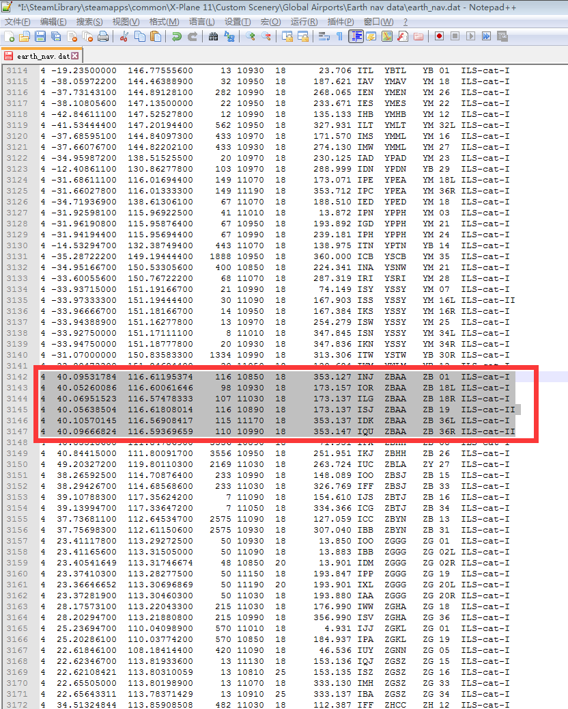

Step 3:

SAVE, exit and reboot X-Plane.